**Lessons Learned on Bayer HealthCare CRM Project**

**ENGSCI 9510L Case Study - Group 31**

**Executive summary**

This report provides brief project introduction and analysis on lessons learned in a global multinational, Bayer HealthCare (BHC), which includes the organization specifications, overview of the cloud program and lessons decomposition in different phases and perspective. As a typical adventure and innovation project, BHC’s choice have revealed some common challenges and particular payoffs, which are our mainly interested to learn.

Since not so many materials are published for BHC’s global project, our study is mainly based on the business analysis articles and news from Internet and journals; meanwhile we also talked to some previous project members to understanding some details and management processes, of course without violating the privacy policy from BHC.

The Table 1 offers us a overall picture of the lessons learned to summarize BHC’s management strategies.

Table 1:

|  |  |
| --- | --- |
| **Lessons Learned at BHC** | |
| Cost Management | #1: Consider Multi-Platform Cloud Strategies #2: Perform a cost competitive vendor review and negotiate contract term #3: Shorten the implementation time for cloud solution |
| Scope Management | #4: Design a Global Template Approach for Rollouts #5: Build strategy to control customization work |
| Schedule Management | #6: keep balance when managing the project schedule |
| Quality Control | #7: In user acceptance test (UAT) phase, make sure all test cases are related and only related to the sign-off requirements. |
| Resource Management |  |
| Organization and Communication |  |
| Risk Management |  |

1. **Introduction**

**Lesson #1: Consider Multi-Platform Cloud Strategies**

Considering the financial strategies as a large multinational project, BHC did not pick up cost-effective solutions separately but chose a unified Cloud-based solution, which would cost more for the smaller country with less requirements, but considering an enterprise-wide solution in long-term picture, the company and project team believed it is a cost-efficient strategy.

Firstly cloud platform will save time and effort to build system infrastructure, meaning the project will devote more time and budget to focus on how to figure out more values for turning the system usage into more business success. Secondly the unified platform solution also means unified processes and key functions for multinational customers, which will highly reduce the cost to implement different customized requirements from different countries to achieve the similar functions.

To achieve commercial excellence in today’s rapidly changing life sciences industry, companies need to create a fully coordinated, relevant customer experience that seamlessly traverses all channels. [1] The global company will not only consider the project cost saving from short-term technical perspective when selecting the solution proposals, but also be aware of need for a mutual solution with business value growth.

**Lesson #2(cost management) Perform a cost competitive vendor review and negotiate contract term**

BHC has its own IT team globally to in charge of the development, maintenance and support for various systems, however BHC tend not to put more cost in developing new functions in this enterprise-wide cloud platform system, on the contrary BHC choose to build partnership with third party vendors through the negotiate contractual terms, vendors are really cherish the ‘cake’ like BHC’ size and tend to offer cost-reducing benefit in the partnership, which includes providing continuous new product features as Saas (Software as a service) in cloud platform to enhance the pharmacy solutions. Meanwhile, the BHC’s project team also keep controlling and tracking the function rollout, which is win-win cooperation. Here is the comments from the head of CRM Program Management: “the collaboration with the Saas vendor for pharma has helped us to minimize Paas-based custom development needs in the long run and to provide a standard solution also for the over-the-counter business of the non-pharma units”[3]

**Lesson #3(cost and time management) Shorten the implementation time for cloud solution**

Selecting cloud solution costs BHC a lot since the license fee will be charged annually, however how does the project team make their boss feel worthy and actually saving the finance in big picture? The answer would be shorten the project time with high quality delivery.

One of the advantages of mutual CRM cloud solution is that it can be implemented quickly in a “plug-and-play” style to reduce the project timeline. On the other hand, the key future requirements collected by project team from workshop will propose to the cloud product vendor firstly as new service feature, once the feature is accepted, it will be free released in next version after 4 month, which will save a lot of project budget and time in current project phase.

**Lesson #4 (Scope Management) Design a Global Template Approach for Rollouts**

Similar to select the system platform we mentioned in the Lesson #1, BHC realized the most cost effective way is not trying to implement as many different requirements as possible from each country in lowest budget. Instead, as the BHC case shows, companies chose a template-based rollout approach where a global template for the target processes and systems is developed during one or very few concurrent pilots, before rollouts to other entities can proceed at a more accelerated rate [2].

Unlike the risky ‘big bang’ strategy of doing anything at once, BHC is willing to focus on the key features firstly in pilot phase to well control the scope and cost, the global template not only defined the data schema but also provide the key processes designed by business expert to fulfill multinational requirements. Under this methodology, the project scope is well controlled, when customers want to propose a new requirement just flashed in the brain, they should consider twice if this is the key function which will bring business values, if it is following the global template. All the stakeholders can reach an agreement on this policy, the communication will become more effective and project team will allocate sufficient cost and resources to initiate template and continuous adaptation for different countries’ rollouts.

Actually BCH have paid a price for having rushed the template definition and trying to implement several pilots concurrently in a too agile trend, after a period of halt and heated discussion, the project team adapted the policy and transited to a relatively steady stage for sequential releases rollouts. The first rollout country’s most features have become the design blueprint for the future global processes.

**Lesson #5 (scope management) Build strategy to control customization work**

In current mutual pharm-industry based cloud solution, most common functions can be covered ‘out of the box’, BHC set up a strategy to control the project scope for different countries and business unit, especially for non-pharma customization requirements (See Figure 1 [2]).

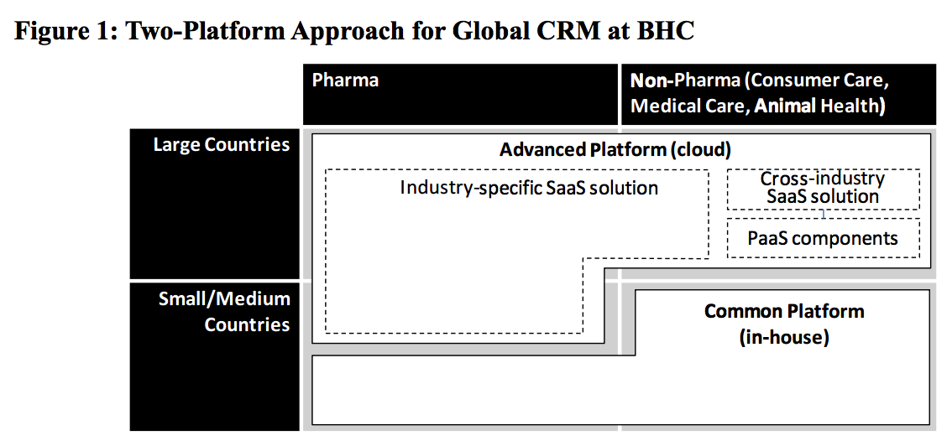

For example, in China Pharma’s workshop, project team proposed adapting the industry-specific Saas solution to replace the customized or uncertain processes on ‘sample management’ module, according to which the work scope will be focused on the platform approach to avoid customization effort and risk.

**Lessons #6 (schedule management) keep balance when managing the project schedule**

PM should be fully aware of the workload usage peak and buffer in different phases, and then make a relatively balanced schedule, especially for the local development team or vendors.

In the pilot project for China BHC, the local vendor devoted more than expected overtime workload to implement one customization feature, in order to motive the team to keep on working and finish according to the time schedule , the project team offered an additional contact to pay more in following scheduled pilot rollout phase, to support the end user before the call center is fully ready, apparently this is much easier work than the development before. Through this BHC has built better relation and reputation among cloud vendors and fitted the schedule accordingly since more resources were involved by the new contact.

**Lesson #7: (Quality Management) In user acceptance test (UAT) phase, make sure all test cases are related and only related to the sign-off requirements.**

When project team did the system integration test, lots of issues should be relevant to the platform or technique issues; When the system are ready to show to end users for UAT, a well organized test cases was very necessary.

Firstly the test cases mapping to specific requirement items will remind the testers the function they used to propose, in this way they will feel better impression on the system psychologically. Secondly strictly mapped quality goal will strive both the development team and testers focusing on the key functions in the scope, instead of imagine some other comments on the features out of the scope, according to which the project team will save much extra communication effort but set the more valuable target to pass the UAT.

In a global project with multiple channels, the well negotiated and sign-off requirement document is the key step based on which the following phase will focus on the implementation in the signed scope, the change requests and system quality will be well managed and predicted.

[1] <https://www.veeva.com/products/multichannel-crm/>

[2] <Bayer HealthCare Delivers a Dose of Reality for Cloud Payoff Mantras in Multinationals>